# **Name: Abdurrahman Qureshi**

# **Roll No: 242466**

Assignment No: 2

Date Of Performance: 10/10/2025

Q: Implementation of Nodejs/ Express Rest API applications.

CODE (src/app/api/*):

==> delete/pinata/delete-file/route.ts

import { NextResponse } from "next/server";

import { pinata } from "@/lib/pinata/config";

export async function DELETE(request: Request) {

try {

const { id } = await request.json();

if (!id) {

return NextResponse.json(

{ error: "File ID is required" },

{ status: 400 }

);

}

const deletedFiles = await pinata.files.public.delete([id]);

return NextResponse.json(deletedFiles, { status: 200 });

} catch (e) {

console.error("Server error:", e);

return NextResponse.json(

{ error: "Internal server error" },

{ status: 500 }

);

}

}

==> get/neon/orders/fetch-all/route.ts

import { NextResponse } from "next/server";

import pool from "@/lib/neon/config";

export async function GET() {

try {

const query = `

SELECT * FROM "orders"

ORDER BY ordered_at DESC;

`;

const result = await pool.query(query);

return NextResponse.json({

data: result.rows,

status: true,

});

} catch (error) {

console.error("Error fetching all orders:", error);

return NextResponse.json(

{ error: String(error), status: false },

{ status: 500 }

);

}

}

==> get/neon/orders/in-cart/route.ts

import { NextResponse } from "next/server";

import pool from "@/lib/neon/config";

export async function GET() {

try {

const query = `

SELECT * FROM "orders"

WHERE in_cart = true

ORDER BY ordered_at DESC;

`;

const result = await pool.query(query);

return NextResponse.json({

data: result.rows,

status: true,

});

} catch (error) {

console.error("Error fetching cart orders:", error);

return NextResponse.json(

{ error: String(error), status: false },

{ status: 500 }

);

}

}

==> get/neon/orders/pending-orders/route.ts

import { NextResponse } from "next/server";

import pool from "@/lib/neon/config";

export async function GET() {

try {

const query = `

SELECT * FROM "orders"

WHERE order_status = 'pending'

ORDER BY ordered_at ASC;

`;

const result = await pool.query(query);

return NextResponse.json({

data: result.rows,

status: true,

});

} catch (error) {

console.error("Error fetching pending orders:", error);

return NextResponse.json(

{ error: String(error), status: false },

{ status: 500 }

);

}

}

==> get/neon/prints/fetch-all/route.ts

import { NextResponse } from "next/server";

import pool from "@/lib/neon/config";

export async function GET() {

try {

const result = await pool.query(

`SELECT * FROM "prints" ORDER BY uploaded_at ASC;`

);

return NextResponse.json({ data: result.rows, status: true });

} catch (error) {

console.error("Error fetching all prints:", error);

return NextResponse.json(

{ error: String(error), status: false },

{ status: 500 }

);

}

}

==> get/neon/prints/todays-queue/route.ts

import { NextResponse } from "next/server";

import pool from "@/lib/neon/config";

import { PrintRecord } from "@/interfaces/Print";

export async function GET() {

try {

const query = `

SELECT * FROM "prints"

WHERE print_status = $1

ORDER BY uploaded_at DESC;

`;

const result = await pool.query<PrintRecord>(query, ["pending"]);

return NextResponse.json({ data: result.rows, status: true });

} catch (error) {

console.error("Error fetching queue:", error);

return NextResponse.json(

{ error: String(error), status: false },

{ status: 500 }

);

}

}

==> patch/neon/orders/cancel-order/route.ts

import pool from "@/lib/neon/config";

import { NextResponse } from "next/server";

export async function PATCH(req: Request) {

try {

const body = await req.json();

const { order_id } = body;

if (!order_id) {

return NextResponse.json(

{

error: "Order ID is required to cancel order",

status: false,

},

{ status: 400 }

);

}

const query = `

UPDATE "orders"

SET

order_status = 'cancelled'

WHERE order_id = $1

RETURNING *;

`;

const values = [order_id];

const result = await pool.query(query, values);

if (result.rows.length 0) {

return NextResponse.json(

{ error: "Order not found", status: false },

{ status: 404 }

);

}

return NextResponse.json({

data: result.rows[0],

message: "Order cancelled successfully",

status: true,

});

} catch (error) {

console.error("Error cancelling order:", error);

return NextResponse.json(

{ error: String(error), status: false },

{ status: 500 }

);

}

}

==> patch/neon/orders/checkout-order/route.ts

import pool from "@/lib/neon/config";

import { NextResponse } from "next/server";

export async function PATCH(req: Request) {

try {

const body = await req.json();

const { order_id } = body;

if (!order_id) {

return NextResponse.json(

{

error: "Order ID is required to cancel order",

status: false,

},

{ status: 400 }

);

}

const query = `

UPDATE "orders"

SET

order_status = 'pending',

in_cart = false

WHERE order_id = $1

RETURNING *;

`;

const values = [order_id];

const result = await pool.query(query, values);

if (result.rows.length 0) {

return NextResponse.json(

{ error: "Order not found", status: false },

{ status: 404 }

);

}

return NextResponse.json({

data: result.rows[0],

message: "Order cancelled successfully",

status: true,

});

} catch (error) {

console.error("Error cancelling order:", error);

return NextResponse.json(

{ error: String(error), status: false },

{ status: 500 }

);

}

}

==> patch/neon/prints/complete-print/route.ts

import { NextResponse } from "next/server";

import pool from "@/lib/neon/config";

export async function PATCH(req: Request) {

try {

const { print_id } = await req.json();

if (!print_id) {

return NextResponse.json(

{ error: "Print ID is required", status: false },

{ status: 400 }

);

}

const query = `

UPDATE "prints"

SET print_status = 'completed'

WHERE print_id = $1

RETURNING *;

`;

const values = [print_id];

const result = await pool.query(query, values);

if (result.rows.length 0) {

return NextResponse.json(

{ error: "Print not found", status: false },

{ status: 404 }

);

}

return NextResponse.json({

data: result.rows[0],

message: "Print cancelled successfully",

status: true,

});

} catch (error) {

console.error("Error cancelling:", error);

return NextResponse.json(

{ error: String(error), status: false },

{ status: 500 }

);

}

}

==> post/neon/orders/insert-record/route.ts

import { NextResponse } from "next/server";

import pool from "@/lib/neon/config";

import { getFormatDate } from "@/functions/utility";

export async function POST(req: Request) {

try {

const body = await req.json();

const { order, user } = body;

const query = `

INSERT INTO "orders" (

item_id,

user_id,

user_name,

item_name,

item_category,

item_type,

item_quantity,

item_price,

instructions,

ordered_at,

order_status,

in_cart

) VALUES ($1, $2, $3, $4, $5, $6, $7, $8, $9, $10, $11, $12)

RETURNING *;

`;

const values = [

order.item_id,

user.id,

user.fullName,

order.item_name,

order.item_category,

order.item_type,

order.item_quantity,

order.item_price,

order.instructions,

getFormatDate(new Date()),

order.order_status,

order.in_cart,

];

const result = await pool.query(query, values);

return NextResponse.json({ data: result.rows, status: true });

} catch (error) {

console.error("Error inserting:", error);

return NextResponse.json(

{ error: String(error), status: false },

{ status: 500 }

);

}

}

==> post/neon/orders/user-history/route.ts

import { NextResponse } from "next/server";

import pool from "@/lib/neon/config";

export async function POST(req: Request) {

try {

const { user } = await req.json();

const query = `

SELECT * FROM "orders"

WHERE user_id = $1

ORDER BY ordered_at ASC;

`;

const result = await pool.query(query, [user.id]);

return NextResponse.json({ data: result.rows, status: true });

} catch (error) {

console.error("Error fetching user history:", error);

return NextResponse.json(

{ error: String(error), status: false },

{ status: 500 }

);

}

}

==> post/neon/prints/check-hash/route.ts

import { NextResponse } from "next/server";

import pool from "@/lib/neon/config";

export async function POST(req: Request) {

try {

const { hashed_content } = await req.json();

const query = `

SELECT * FROM "prints"

WHERE hashed_content = $1

`;

const result = await pool.query(query, [hashed_content]);

if (result.rows.length > 0) {

return NextResponse.json({

fileExists: true,

status: true,

numberOfRows: result.rows.length,

existsResult: {

hashed_content: result.rows[0].hashed_content,

ipfs_id: result.rows[0].ipfs_id,

ipfs_url: result.rows[0].ipfs_link,

},

});

}

return NextResponse.json({

fileExists: false,

numberOfRows: result.rows.length,

status: true,

});

} catch (error) {

console.error("Error fetching user history:", error);

return NextResponse.json(

{ error: String(error), status: false },

{ status: 500 }

);

}

}

==> post/neon/prints/insert-record/route.ts

import { NextResponse } from "next/server";

import pool from "@/lib/neon/config";

import { getFormatDate } from "@/functions/utility";

import { generatePrintId } from "@/functions/prints";

export async function POST(req: Request) {

try {

const body = await req.json();

const { pinataResult, file, user } = body;

const query = `

INSERT INTO "prints" (

print_id,

user_id,

user_name,

file_name,

file_type,

ipfs_id,

ipfs_link,

hashed_content,

print_count,

page_count,

print_type,

print_color,

binding_type,

instructions,

print_status,

uploaded_at

) VALUES ($1, $2, $3, $4, $5, $6, $7, $8, $9, $10, $11, $12, $13, $14, $15, $16)

RETURNING *;

`;

const values = [

generatePrintId(),

user.id,

user.fullName,

file.file_name,

file.file_type,

pinataResult.ipfs_id,

pinataResult.ipfs_url,

file.hashed_content,

file.print_count,

file.page_count,

file.print_type,

file.print_color,

file.binding_type,

file.instructions || "",

"pending",

getFormatDate(new Date()),

];

const result = await pool.query(query, values);

return NextResponse.json({ data: result.rows, status: true });

} catch (error) {

console.error("Error inserting:", error);

return NextResponse.json(

{ error: String(error), status: false },

{ status: 500 }

);

}

}

==> post/neon/prints/user-history/route.ts

import { NextResponse } from "next/server";

import pool from "@/lib/neon/config";

export async function POST(req: Request) {

try {

const { user } = await req.json();

const query = `

SELECT * FROM "prints"

WHERE user_id = $1

ORDER BY uploaded_at ASC;

`;

const result = await pool.query(query, [user.id]);

return NextResponse.json({ data: result.rows, status: true });

} catch (error) {

console.error("Error fetching user history:", error);

return NextResponse.json(

{ error: String(error), status: false },

{ status: 500 }

);

}

}

==> post/pinata/update-file/route.ts

import { NextResponse, type NextRequest } from "next/server";

import { pinata } from "@/lib/pinata/config";

export async function POST(request: NextRequest) {

try {

const { id, file_name } = await request.json();

if (!id || !file_name) {

return NextResponse.json(

{ error: "No file provided" },

{ status: 400 }

);

}

const result = await pinata.files.public.update({

id: id,

name: file_name,

});

return NextResponse.json(

{

id: result.id,

name: result.name,

ipfs_cid: result.cid,

},

{ status: 200 }

);

} catch (e) {

console.error("Pinata upload error:", e);

return NextResponse.json(

{ error: "Internal Server Error" },

{ status: 500 }

);

}

}

==> post/pinata/upload-files/route.ts

import { NextResponse, type NextRequest } from "next/server";

import { pinata } from "@/lib/pinata/config";

export async function POST(request: NextRequest) {

try {

const data = await request.formData();

const file: File | null = data.get("file") as unknown as File;

if (!file) {

return NextResponse.json(

{ error: "No file provided" },

{ status: 400 }

);

}

const result = await pinata.upload.public.file(file);

const url = await pinata.gateways.public.convert(result.cid);

return NextResponse.json(

{

id: result.id,

ipfs_hash: result.cid,

ipfs_url: url,

},

{ status: 200 }

);

} catch (e) {

console.error("Pinata upload error:", e);

return NextResponse.json(

{ error: "Internal Server Error" },

{ status: 500 }

);

}

}

==> put/neon/prints/update-print/route.ts

import { NextResponse } from "next/server";

import pool from "@/lib/neon/config";

export async function PUT(req: Request) {

try {

const { document } = await req.json();

const query = `

UPDATE "prints"

SET

page_count = $1,

print_count = $2,

print_type = $3,

print_color = $4,

binding_type = $5,

instructions = $6

WHERE print_id = $7

RETURNING *;

`;

const values = [

document.page_count,

document.print_count,

document.print_type,

document.print_color,

document.binding_type,

document.instructions,

document.print_id,

];

const result = await pool.query(query, values);

return NextResponse.json({ data: result.rows[0], status: true });

} catch (error) {

console.error("Error updating:", error);

return NextResponse.json(

{ error: String(error), status: false },

{ status: 500 }

);

}

}

OUTPUT:

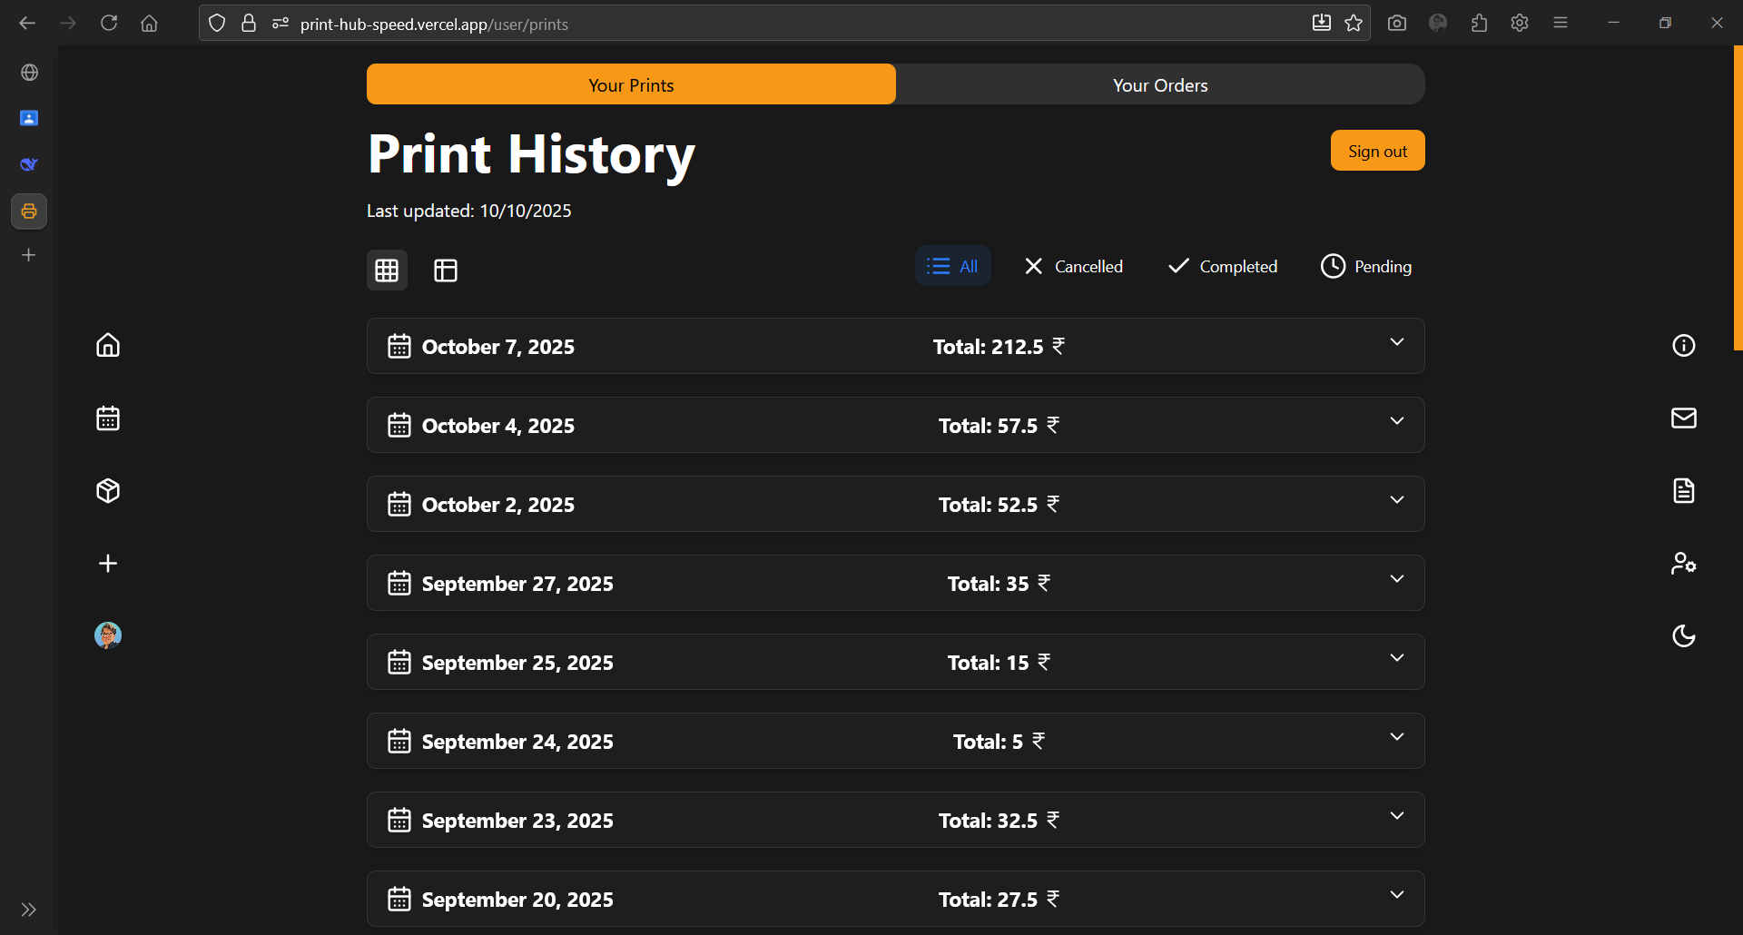

User History (Prints) Page

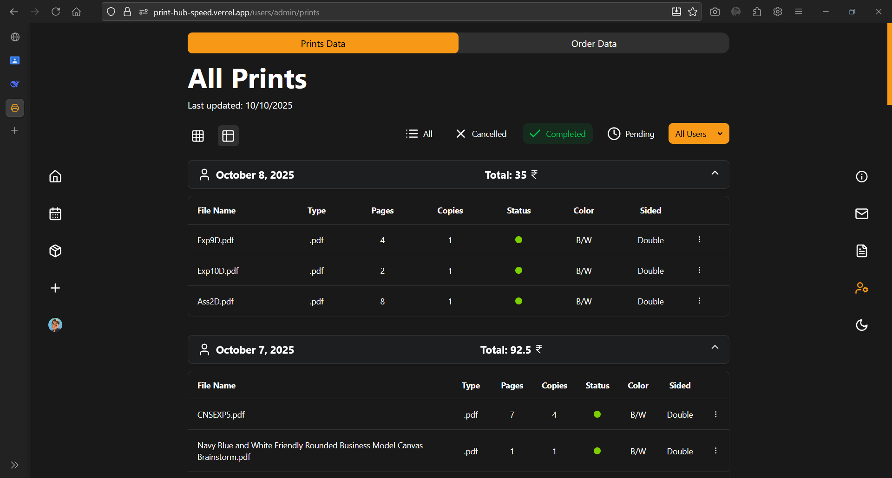

All orders Page (Admin)

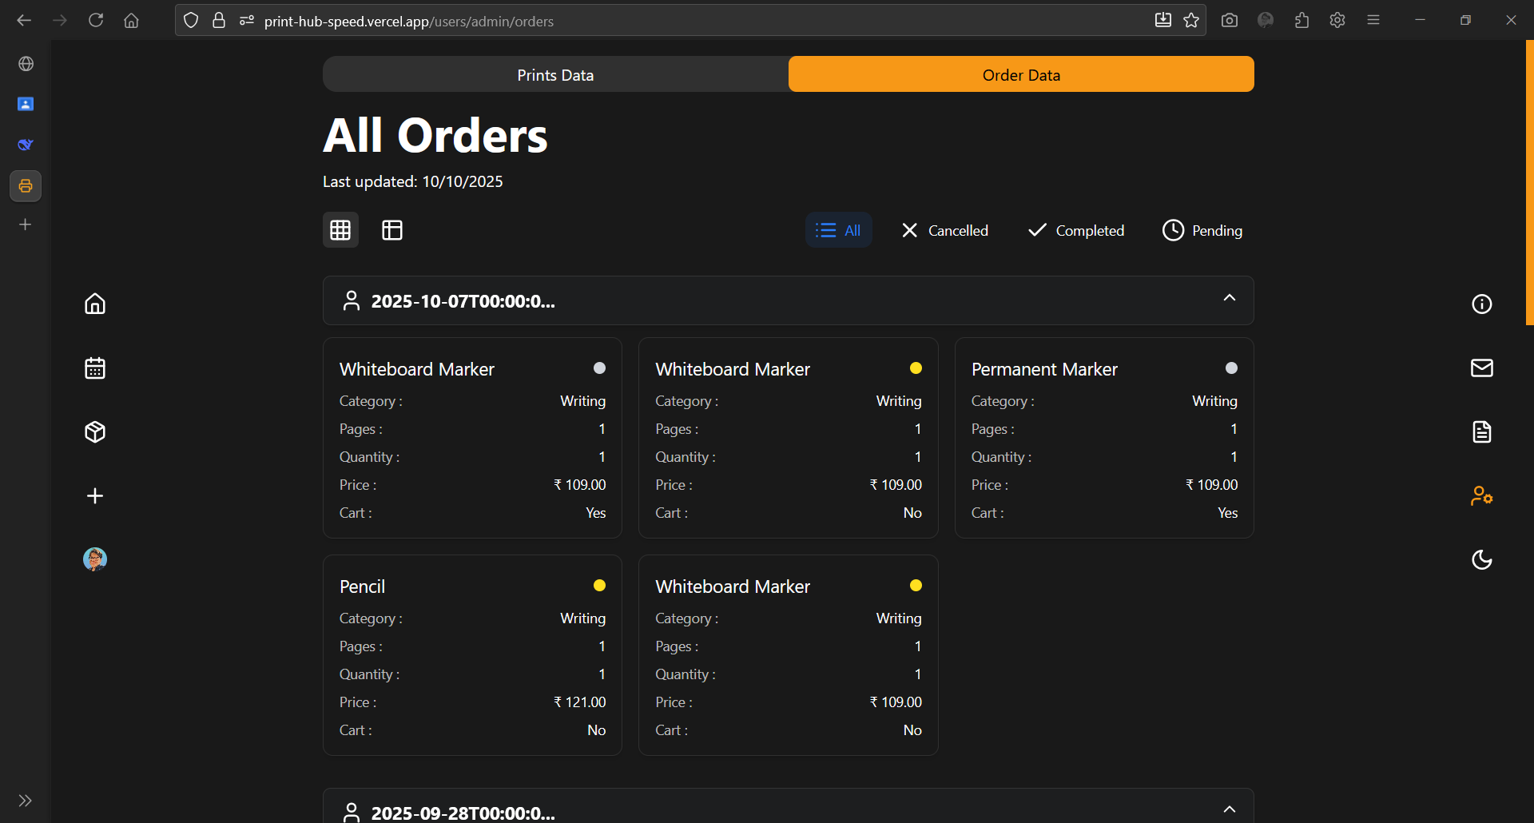

All orders Page (Admin)

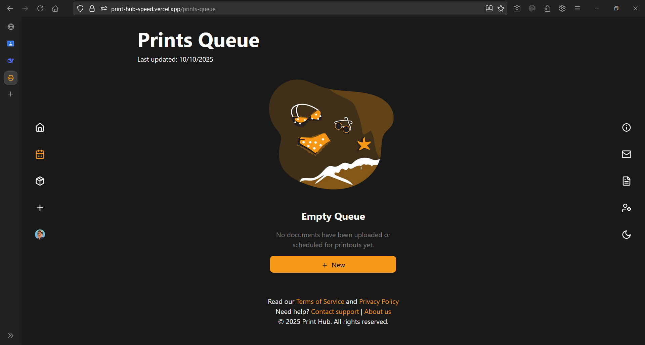

Prints Queue Page



Pending Orders Page